Master of AI
Faculty of Engineering & IT
42172 AT2 Group Project Design & Plan
UTS CRICOS 00099F
PROJECT GROUP NUMBER: [ ]

AUTHORS: [NAME, STUDENT ID] · [NAME, STUDENT ID] · [NAME, STUDENT ID]

DATE: 23 OCTOBER 2026

SEMESTER: SPRING

YEAR: 2026

UNIVERSITY OF TECHNOLOGY SYDNEY
(Table of Contents: List all the major sections of the report with page numbers (commencing page for each section). You can use your word processor to do this automatically for you.)

Table of Contents
Table of Contents 2
Summary or Executive Summary 3
Introduction 4
Business context 4
Problem statement 4
Stakeholder analysis 5
System requirements 6
Project Proposal 7
Project aims and Objectives 7
Methodology 7
Expected outcomes 7
Benefits and significance of this project 7
Resources 7
Risks 8
Timeline 8
Communication of expected outcomes 8
Solution design 9
Technique 1: Computer vision (U-Net convolutional networks) 9
Technique 2: Sequential models 9
Technique 3: Next-generation foundation models 10
Technique comparison and integration 10
Implementation design 10
Evaluation design 10
Risk management 11
List of References 12
Appendices 13
Appendix A: Team progress log 13

Summary or Executive Summary
Write last, maximum one page. Cover: the problem and its cost, the three AI techniques and how they combine, expected outcomes, how success will be measured, and the main risks. Owner: [ ]. Guidance in grey italic is for the team: delete it before submission. Yellow highlight marks text that was corrected or still needs a source.

Introduction
Two or three sentences that tell the reader where the report is going. Owner: [ ].

Business context
Current disaster response frameworks suffer from a structural mismatch between the physics of extreme weather and the operational latency of predictive systems. We call this gap the spatiotemporal operational blindspot in rapid-onset flash flood forecasting.
Layer | Spatial scale | Time scale
Global weather models | About 9 km grids (ECMWF high-resolution forecast) | 6-hour update cycles
Operational blindspot | Valley and catchment scale | 0 to 12 hours ahead
Ground reality | 100 m valley scale | Flooding within 6 hours of heavy rain, often within 3 (National Weather Service, n.d.)

Flash floods are among the deadliest flood types per person affected because of their rapid onset [source needed; candidate: Jonkman, 2005, check]. The US National Weather Service defines a flash flood as flooding from heavy rain in a short period, generally under 6 hours and often under 3 (National Weather Service, n.d.). Solving the blindspot is driven by three societal imperatives.
Human mortality and evacuation paralysis. In rapid-onset inundation, lead time determines survival. A delayed warning turns an orderly vehicle evacuation into rooftop rescues, swift-water deployments and vehicle drownings, which account for about half of Australian flood fatalities (FitzGerald et al., 2010; Haynes et al., 2017). The 2022 Lismore flood shows the cost of forecast error: the Wilsons River reached 14.4 m, 2 m above previous records, two days after the Bureau of Meteorology forecast minor to moderate flooding (Australian Institute for Disaster Resilience [AIDR], n.d.).
Infrastructure failure and economic damage. Unanticipated flash flooding washes away bridges, submerges electrical substations and contaminates water treatment plants. Advance warning at catchment resolution lets utilities de-energise vulnerable substations, reroute water supply and pre-stage response assets before access is cut. [Check: the earlier draft promised 12 to 24 hour warnings at 2 km; confirm our techniques can support that lead time before stating it.]
Collapse of public trust through alert fatigue. Coarse models force agencies to issue blanket warnings over tens of thousands of square kilometres. Frequent false alarms teach residents to ignore warnings during real events. Precise, local and timely alerts restore compliance.

Problem statement
Template asks for: the problem and its context; why it is a problem; why the project is necessary; how it will be solved, briefly.
The blindspot stems from three compounding technical bottlenecks.
· The spatial resolution deficit. Global numerical weather prediction models such as GFS and ECMWF run on grids of around 9 km or coarser (ECMWF, 2016). A grid cell of that size averages out convective storm cells, micro-bursts and orographic lifting, missing the narrow valleys where flash floods start.
· The numerical latency bottleneck. High-resolution physics simulations (for example WRF or 2D hydrodynamic flood models) take 4 to 6 hours [source needed] on high-performance clusters. By the time a run finishes, the rain has fallen and rivers have peaked.
· The ungauged basin blindspot. Streamflow models are calibrated on river gauge records, yet over 70% of regional tributaries and headwater creeks are ungauged [source needed], leaving statistical and hydrological models blind where flash floods begin.
How we will solve it, briefly: we define one prediction target, the probability that a flash flood occurs in a catchment within the next 6 hours [team to confirm]. Each team member develops one AI technique that predicts this target: a computer vision model, a sequential model and a foundation model. All three are trained and tested on the same data and judged on the same measures, and the best-performing candidate is selected for deployment, with human controllers approving every public alert.

Stakeholder analysis
Not a template heading, but the first rubric criterion marks end-users, stakeholders, diverse needs and constraints. Keep it.
Tier | Stakeholders | Needs | Constraints
1. Operational commanders | SES incident controllers, Bureau of Meteorology hydrologists, local emergency management committees | Predictions that update with every radar scan (every 5 to 10 minutes); 2 km rainfall and 10 m flood maps; calibrated uncertainty bounds | High cognitive load under time pressure; every alert must be explainable and verifiable before an evacuation order is signed
2. Frontline responders | Police, swift-water rescue, paramedics | Which bridges, causeways and roads will be under water at T+2, T+4 and T+6 hours | Degraded mobile coverage, low bandwidth, hostile field conditions
3. Affected communities | Valley residents, farmers, elderly people, linguistically diverse communities, people with limited mobility | Clear directives (e.g. "Oak Street bridge will flood by 4:00 pm; leave north via High Ridge Road now"), delivered by SMS, sirens, radio and apps | Digital and language barriers; people who rely on public transport or carers need extra lead time
4. Infrastructure operators | Energy distributors (e.g. Essential Energy), water authorities, Transport for NSW | Flood depth forecasts mapped against their asset locations | False alarms are costly: de-energising a grid disrupts hospitals, business and sanitation

System requirements
Each requirement traces back to a stakeholder need above. Requirements describe what the system must deliver, whichever candidate technique is selected, so all three are judged against the same list. The earlier technique-specific requirements (radar ingestion, diffusion downscaling, zero-shot streamflow) now belong in the individual technique sections as approaches.
ID | Requirement | Stakeholder need it serves
FR-1 | Predict the probability of a flash flood in each catchment within the next 6 hours [team to confirm target], refreshed with every radar update. | Timely, local warnings for controllers and communities (Tiers 1 and 3)
FR-2 | Use inputs that are available in real time: ground weather radar every 5 to 10 minutes, rain gauges, and static terrain, soil and land-cover layers. Sentinel-1 satellite flood maps, available every few days, serve as ground truth after events (European Space Agency [ESA], n.d.). | Works operationally, not only in hindsight (Tier 1)
FR-3 | Produce forecasts for catchments without a river gauge | Covers rural and headwater communities left blind by gauge-based models (Tier 3)
FR-4 | Report the main drivers behind each high-risk prediction (e.g. recent rainfall, slope, soil wetness) | Controllers must verify an alert before signing an evacuation order (Tier 1)
NFR-1 | End-to-end inference under 90 seconds per regional sweep | Fits inside the 5 to 10 minute radar cycle (Tier 1)
NFR-2 | Catchment-level forecasts; 10 m flood maps for verification | Crews can identify affected roads and bridges (Tier 2)
SR-1 | Human in the loop: the system recommends, a controller signs off every public alert | Prevents AI errors triggering unwarranted mass evacuations
SR-2 | Set the alert threshold to a high recall target, [target to be agreed], while keeping the false alarm ratio within an agreed limit. | Balances life safety against alert fatigue and economic cost (Tiers 3 and 4)

Project Proposal

Project aims and Objectives
One aim, then three to five measurable objectives, each tied to a requirement above. Owner: [ ].
· Aim: give NSW river valleys reliable flash flood warnings in the 0 to 6 hour window.
· O1: build a shared, labelled dataset of past flash flood events and their inputs (FR-2).
· O2: develop three candidate predictors of the shared target: computer vision, sequential, foundation model (FR-1, FR-3).
· O3: compare the candidates on the same held-out events and measures (SR-2).
· O4: select the best candidate and deploy it in an alert workflow with human sign-off (FR-4, SR-1).

Methodology
A task list: what each task is, its expected result and milestone, its time allocation, and which objective it serves. Owner: [ ].
Task | Description | Milestone | Objective
T1 | Shared dataset: event labels from flood records and Sentinel-1 flood maps; radar, gauge and terrain inputs; one train/validation/test split by event | [ ] | O1
T2 | Candidate A: computer vision model | [ ] | O2
T3 | Candidate B: sequential model | [ ] | O2
T4 | Candidate C: foundation model | [ ] | O2
T5 | Common evaluation and head-to-head comparison | [ ] | O3
T6 | Selection, alert logic and controller dashboard | [ ] | O4
T7 | Pilot with one emergency management committee | [ ] | O4

Expected outcomes
What the project delivers on completion: models, alert workflow, dashboard, evaluation report. Owner: [ ].

Benefits and significance of this project
The innovation criterion: show why AI is necessary and better than credible non-AI alternatives (physics models, rainfall thresholds, gauge-based forecasting), with evidence. Make the societal value measurable and equitable. Owner: [ ].

Resources
Team roles and responsibilities for the real project, compute (GPUs for training, low-latency inference), data sources and their costs or licences. Owner: [ ].

Risks
List risk factors from technical to social: personnel, data, compute, deployment. Mitigations go in Risk management below. Owner: [ ].

Timeline
Time frame for the whole project and each task. A Gantt chart works well as a figure. Owner: [ ].

Communication of expected outcomes
How results reach stakeholders: agency briefings, community alerts, publications, open data. Owner: [ ].

Solution design
The technique criterion is worth 2.4 of 12 marks. It rewards candidate techniques "matching with group size", explained precisely, compared critically on problem-relevant criteria with evidence, and a selection justified through explicit trade-offs.

Shared target and comparison protocol
Target: the probability that a flash flood occurs in a catchment within the next 6 hours [team to confirm]. A positive label means a recorded flash flood in that catchment in that window.
Common inputs: radar rainfall, rain gauges, terrain, soil and land cover. Each technique may represent them differently (images, time series or foundation-model embeddings), but no candidate gets data the others cannot use.
Common test: the same train, validation and test split by event, with the 2022 Lismore flood held out as an unseen extreme event [check data availability]. The same metrics for all three, defined in Evaluation design.
Each technique section below follows the same structure: how it predicts the target, data and resources, evidence from the literature, alternatives considered within that family, strengths and limitations.

Candidate A: Computer vision (convolutional neural network)

A.1 How the CNN predicts the target
A flash flood forms where intense rain lands on steep, saturated ground that funnels water into one channel, so the problem is spatial. That's why we treat each catchment as an image: a stack of map layers describing the rain, the land and how wet it already is. A convolutional neural network (CNN) reads the stack and returns one number, the probability that the catchment floods within the next 6 hours, which is our shared target.

A.2 Inputs
Each input is a 16 km square tile of 64 × 64 cells, each 250 m wide, centred on the catchment. We fixed the cell size so that a value means the same thing in every catchment, and we gave the tile ten channels (Table 5). Rainfall comes in three windows because the network doesn't remember earlier inputs: the windows are how it tells a short burst from hours of steady rain. The last channel is a mask marking the target catchment, since the tile also covers the land around it and the network wouldn't otherwise know which catchment its probability refers to. Implementation design describes how each layer is sourced (Figure 2).
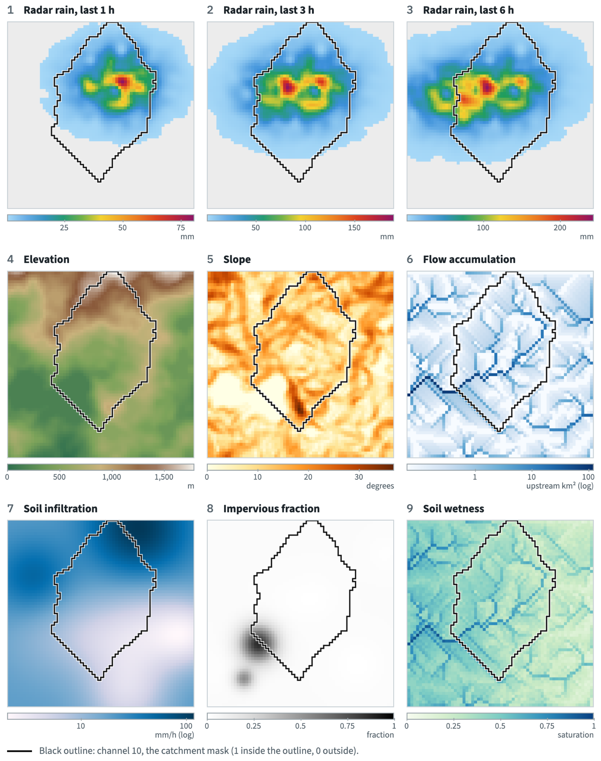
Table 5. The ten input channels
Channel | What each cell holds | Why it matters
1-3 Radar rainfall, last 1, 3 and 6 h | Rain depth (mm) | How intense and how sustained the storm is
4 Elevation | Height (m) | Where water flows from and to
5 Slope | Steepness (degrees) | Steep ground sheds water faster
6 Flow accumulation | Upstream area draining through the cell (km²) | Marks the creeks where water concentrates
7 Soil infiltration | How fast water soaks in (mm/h) | Slow infiltration means more runoff
8 Impervious fraction | Share of the cell sealed by roads and roofs | Sealed ground sends rain straight to drains
9 Soil wetness | Saturation before the storm (0 to 1) | Saturated ground can't absorb more rain
10 Catchment mask | 1 inside the catchment, 0 outside | Tells the network which catchment it's predicting

A.3 Architecture
Figure 1 shows the network. Three convolution blocks learn spatial patterns at growing scales: the first block's 3 × 3 filters span all ten channels at once, so a single filter can respond to heavy rain falling on a steep, wet cell, and the later blocks combine those patterns into hillside- and catchment-scale ones. Pooling halves the grid after each block, and a small dense layer turns the result into one sigmoid output, the flood probability. Labels come from recorded flash floods, and the loss is weighted towards the flood class because floods are rare.
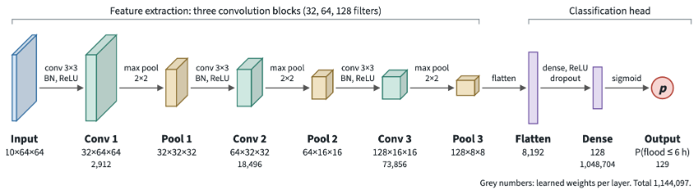
Figure 1. CNN architecture for Candidate A. Grid size halves at each pooling step while the number of feature maps doubles.
> Convolution keeps the network small: a dense layer on the same input would need over four times as many weights in one layer as the whole CNN, and it wouldn't know which cells are neighbours.

A.4 Evidence
Three studies support the choice. A CNN predicted flash flood probability better than a recurrent network on the same Iranian data (AUC 0.832 against 0.814; Panahi et al., 2021), and better than logistic regression and k-nearest neighbours in Pakistan (Ullah et al., 2022). Neither used live rainfall, so our closest support for live rainfall input is Guo et al. (2021), whose CNN mapped terrain and a rainfall event to flood depths in about 0.5% of the time a physics-based model needed.

A.5 Alternatives considered within computer vision
We judged five alternatives on one question: does the method output flash flood probability for a catchment directly, or does it need a second model to get there (Table 6)?
Table 6. Computer vision alternatives considered
Alternative | What it predicts | Why we didn't choose it
Dense network on flattened layers | Same target | Over four times the CNN's weights in one layer; loses which cells are neighbours
U-Net radar nowcast (Ayzel et al., 2020) | Rainfall up to 60 min ahead | Predicts rain, not floods; would need our CNN downstream anyway
Generative nowcast (Ravuri et al., 2021) | Sharper rainfall, 5 to 90 min | Same gap as the U-Net, with far heavier compute
Flood segmentation (Bonafilia et al., 2020) | Water extent after the event | Monitors instead of predicting; we use it to check labels
Pretrained ResNet backbone | Same target | Trained on 3-channel photos; its first layer must be rebuilt for 10 channels

A.6 Strengths and limitations
The CNN suits the requirements: it needs no river gauge (FR-3), should run in well under a second per catchment (NFR-1), and saliency maps can show which cells drove a warning so controllers can check it (FR-4). Its main weakness is memory. It doesn't see rain from before the three windows, which is where the sequential candidate should do better. Radar also misses some rain in mountains, where flash floods start, and the soil-wetness data is coarser than our 250 m grid.

Candidate B: Sequential model
Owner: [ ]. Same structure as Candidate A, predicting the same target. A likely approach is an LSTM over rainfall and gauge time series per catchment; the earlier draft's zero-shot streamflow idea (FR-3 in Section 1) shows how it can cover ungauged catchments.

Candidate C: Next-generation foundation model
Owner: [ ]. Same structure, predicting the same target. A likely approach is fine-tuning a pretrained geospatial or weather foundation model, such as Prithvi (Jakubik et al., 2023), on our labels; the earlier draft's downscaling idea (FR-2 in Section 1) can be its input stage.

Technique comparison
Fill each column from your own section and the shared evaluation results. Every row compares the three on the same target.
Criterion | A: Computer vision | B: Sequential | C: Foundation model
Input representation | Multi-channel spatial images | [ ] | [ ]
Recall / probability of detection | [from evaluation] | [ ] | [ ]
False alarm ratio | [from evaluation] | [ ] | [ ]
Warning lead time | Up to 6 h target window | [ ] | [ ]
Ungauged catchments | Yes: uses radar and terrain, not river gauges | [ ] | [ ]
Data and labels needed | Moderate; labelled flood events | [ ] | [ ]
Explainability (FR-4) | Medium: saliency maps over input layers | [ ] | [ ]
Compute and latency (NFR-1) | Low at inference | [ ] | [ ]
Key weakness | Limited temporal memory; class imbalance | [ ] | [ ]

Selection decision
State which candidate is selected and justify it against the requirements and the comparison table, with explicit trade-offs, e.g. a small loss in recall accepted for much better explainability. Combining candidates is allowed only if the comparison shows it beats the best single model. Owner: whole team.

Implementation design
The data strategy, architecture and workflow criterion is worth 2.4 of 12 marks. Describe the shared data pipeline and how the selected model is deployed. Include: data sources, representation, governance, quality and lifecycle; an architecture diagram with components and interfaces; a workflow diagram showing human oversight, feedback and operational scenarios; development environment and libraries (e.g. Python, PyTorch, Google Earth Engine). Owner: [ ].
Figure 2 traces how one input for Candidate A is built from five data sources that update at three different rates. Every radar scan, roughly every 5 to 10 minutes, we sum the Bureau of Meteorology’s radar rainfall for each cell over the past 1, 3 and 6 hours and resample it from about 1 km to the 250 m grid (channels 1 to 3). Once a day, the Bureau’s AWRA-L soil moisture, modelled on a 5 km grid, is converted to a saturation fraction and interpolated to 250 m (channel 9). Everything else is prepared once. The 30 m elevation model (Gallant et al., 2011) is averaged to 250 m (channel 4), and slope comes from the height difference between neighbouring cells (channel 5). Each cell is then pointed at its steepest downhill neighbour: counting the cells that drain through each one gives flow accumulation (channel 6), and following those directions backwards from a chosen outlet, such as a bridge or the creek entering a town, gives the catchment mask (channel 10). Soil conductivity from the Soil and Landscape Grid of Australia (Grundy et al., 2015) is aggregated from 90 m (channel 7), and the sealed share of each cell comes from land-cover mapping (channel 8). For each outlet, we cut a 64 × 64 tile centred on its catchment from all ten grids and scale every channel with fixed regional constants, never per tile, giving the input to the network in Figure 1. Appendix B shows an example tile.
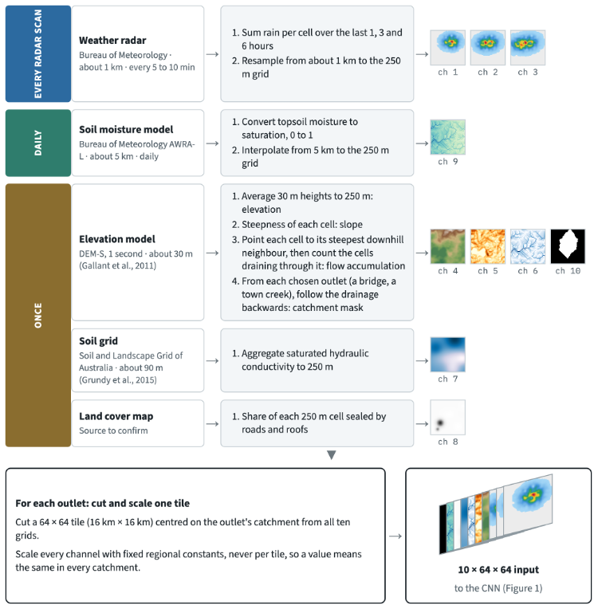
Figure 2. Data pipeline for one Candidate A input. Sources update every radar scan, daily or once; all are brought to the same 250 m grid, cut into a 16 km tile centred on the catchment and scaled.
[Figure 3: system architecture diagram]
[Figure 4: alert workflow with human sign-off and feedback]

Risk management
One mitigation per risk listed under Risks. The rubric names six categories: technical, social, ethical, legal, safety and misuse. Draft rows below.
Category | Risk | Mitigation
Technical | Nowcast skill drops on rare heavy rain, the flash flood case | Select on held-out extreme events, not average skill; conservative thresholds; retrain after each major event
Social | Alert fatigue from false alarms | Catchment-level targeting; false alarm ratio limit in SR-2
Ethical | Unequal radar and gauge coverage gives weaker warnings to rural communities | Report accuracy by region; prioritise data collection in poorly covered areas
Legal | Liability for a missed or wrong warning; data licensing | Human sign-off (SR-1); documented decision trail; licensed data only
Safety | False negative leaves people without warning | High-recall threshold (SR-2); fall back to existing official warnings
Misuse | Spoofed or misinterpreted alerts spread misinformation | Alerts issued only through official channels; authenticated messages

List of References
UTS APA 7th. Highlighted entries need their details checked against the original before submission.
Australian Institute for Disaster Resilience. (n.d.). Flood - New South Wales, 22 February onwards. Australian Disaster Resilience Knowledge Hub. https://knowledge.aidr.org.au/resources/flood-flooding-new-south-wales-2022/
Ayzel, G., Scheffer, T., & Heistermann, M. (2020). RainNet v1.0: A convolutional neural network for radar-based precipitation nowcasting. Geoscientific Model Development, 13(6), 2631-2644. https://doi.org/10.5194/gmd-13-2631-2020
Bonafilia, D., Tellman, B., Anderson, T., & Issenberg, E. (2020). Sen1Floods11: A georeferenced dataset to train and test deep learning flood algorithms for Sentinel-1. In Proceedings of the IEEE/CVF Conference on Computer Vision and Pattern Recognition Workshops (pp. 210-211). https://doi.org/10.1109/CVPRW50498.2020.00113
ECMWF. (2016). New model cycle brings higher resolution. ECMWF Newsletter, 147. https://www.ecmwf.int/sites/default/files/elibrary/2016/17252-new-model-cycle-brings-higher-resolution_0.pdf
European Space Agency. (n.d.). Sentinel-1 revisit and coverage. https://sentinel.esa.int/web/sentinel/user-guides/Sentinel-1-sar/revisit-and-coverage
FitzGerald, G., Du, W., Jamal, A., Clark, M., & Hou, X.-Y. (2010). Flood fatalities in contemporary Australia (1997-2008). Emergency Medicine Australasia, 22(2), 180-186.
Haynes, K., Coates, L., van den Honert, R., Gissing, A., Bird, D., Dimer de Oliveira, F., D'Arcy, R., Smith, C., & Radford, D. (2017). Exploring the circumstances surrounding flood fatalities in Australia, 1900-2015. Environmental Science & Policy, 76, 165-176.
Jakubik, J., Roy, S., Phillips, C. E., et al. (2023). Foundation models for generalist geospatial artificial intelligence (arXiv:2310.18660). arXiv. https://arxiv.org/abs/2310.18660
National Weather Service. (n.d.). Flood and flash flood definitions. https://www.weather.gov/mrx/flood_and_flash
Panahi, M., Jaafari, A., Shirzadi, A., Shahabi, H., Rahmati, O., Omidvar, E., Lee, S., & Bui, D. T. (2021). Deep learning neural networks for spatially explicit prediction of flash flood probability. Geoscience Frontiers, 12(3), 101076.
Ravuri, S., Lenc, K., Willson, M., et al. (2021). Skilful precipitation nowcasting using deep generative models of radar. Nature, 597(7878), 672-677. https://doi.org/10.1038/s41586-021-03854-z
Ullah, K., Wang, Y., Fang, Z., Wang, L., & Rahman, M. (2022). Multi-hazard susceptibility mapping based on convolutional neural networks. Geoscience Frontiers, 13(5), 101425. https://doi.org/10.1016/j.gsf.2022.101425

Appendices
Supporting material that would break the 20-page limit: detailed data tables, extra diagrams, the team progress log.

Appendix A: Team progress log
Date | Member | Work done

